How to access Google Docs From home:
1. Click on “sign in” in the upper-right hand corner of the Google search page
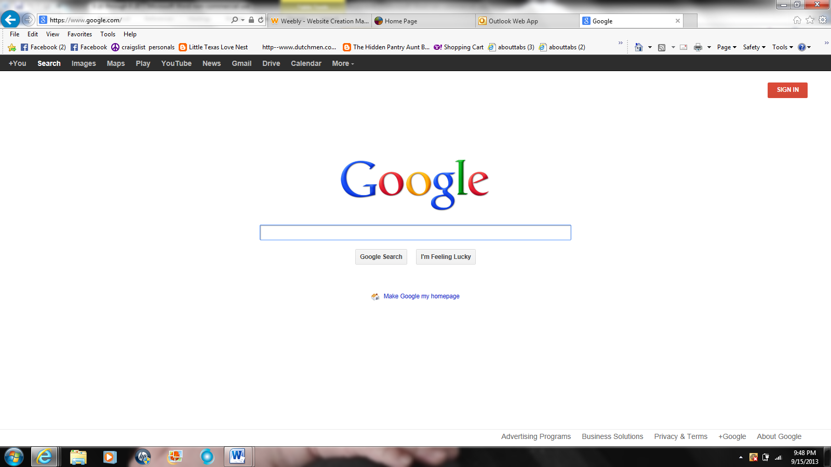
2. Use your Clinton e-mail address to sign in (remember to add the year to the end of it). Your password is the same you use to log on at school.
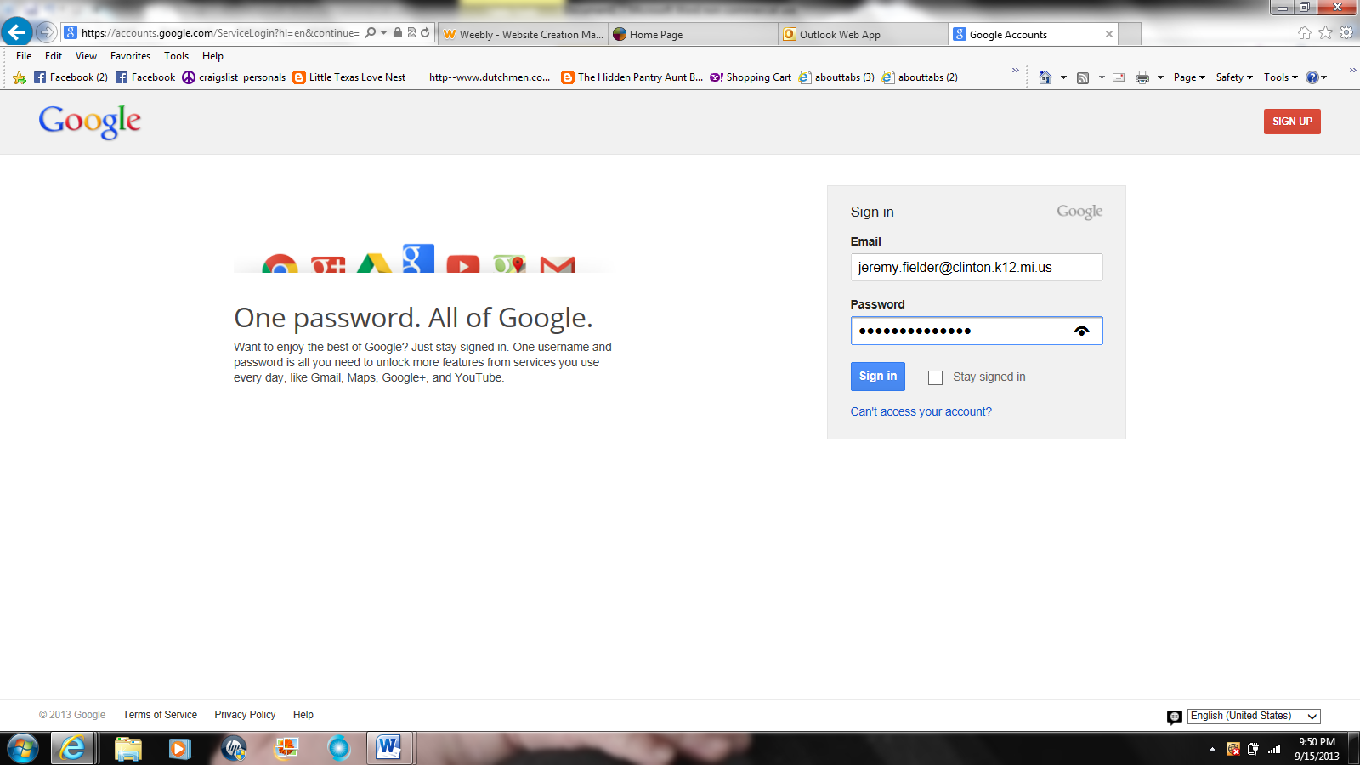

3. You will type “ccs\user.name.year” in the box, then your password you use to sign onto the computers at school.
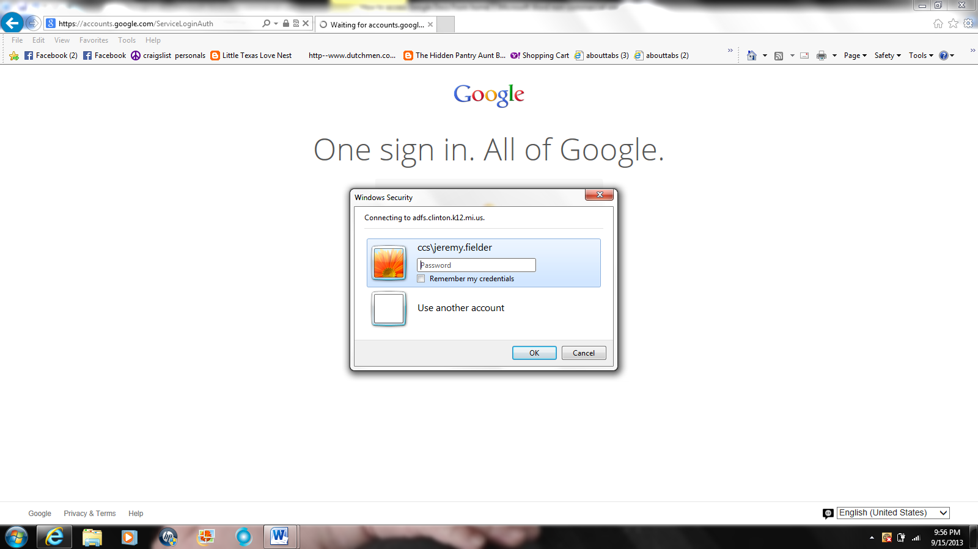
4. Click on “Drive” at the top of the screen.
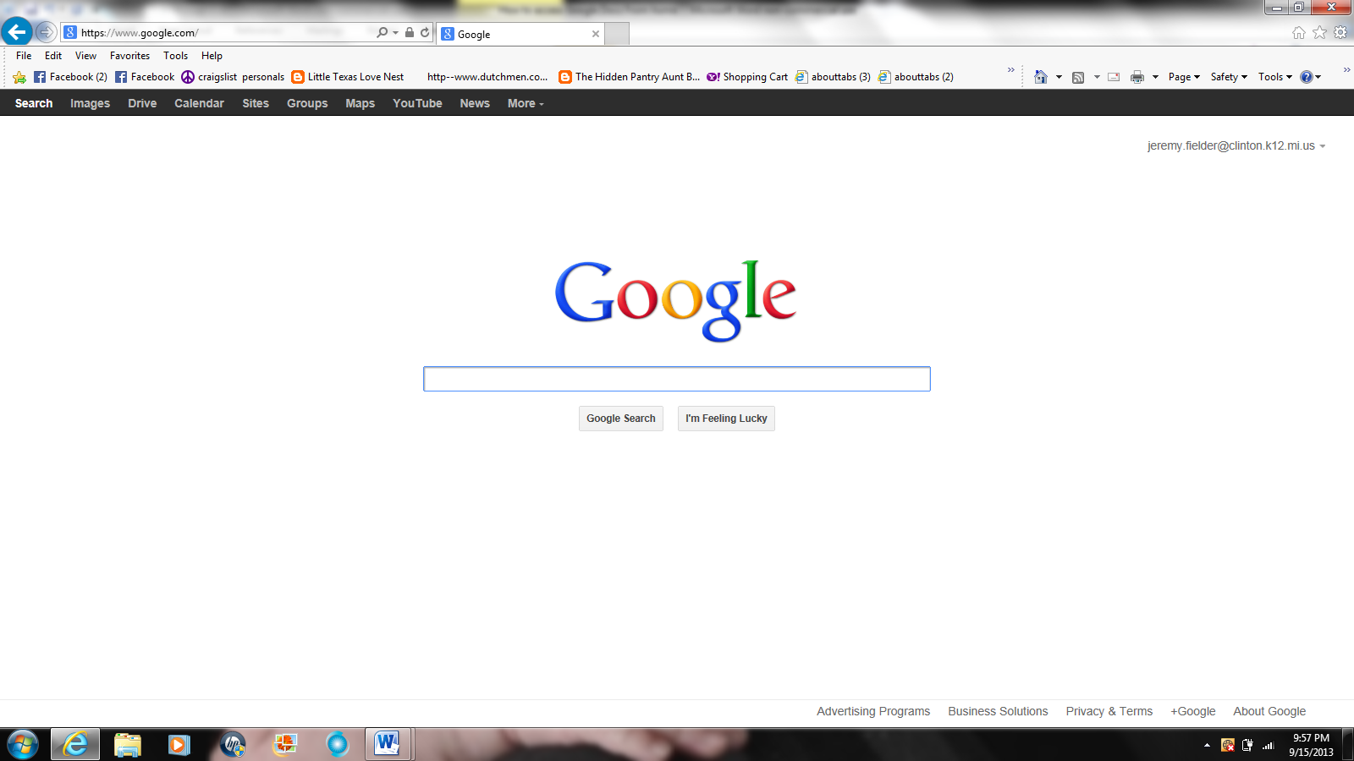

5. Click on “Create” to begin a new document.
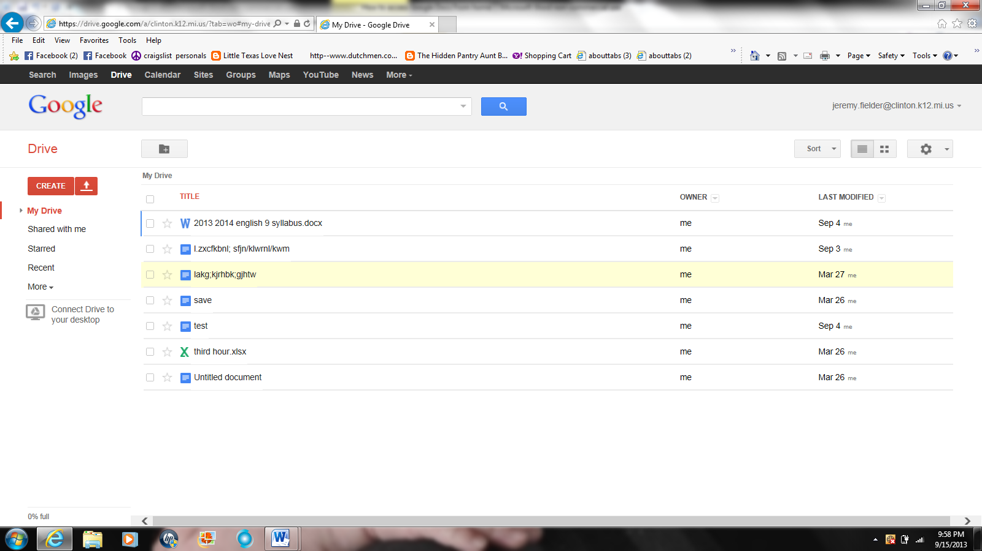
6. Type as you would a word document.
7. When you are finished, click “share” in the upper-right hand corner and make sure you write my Clinton e-mail address in order to share the document with me.
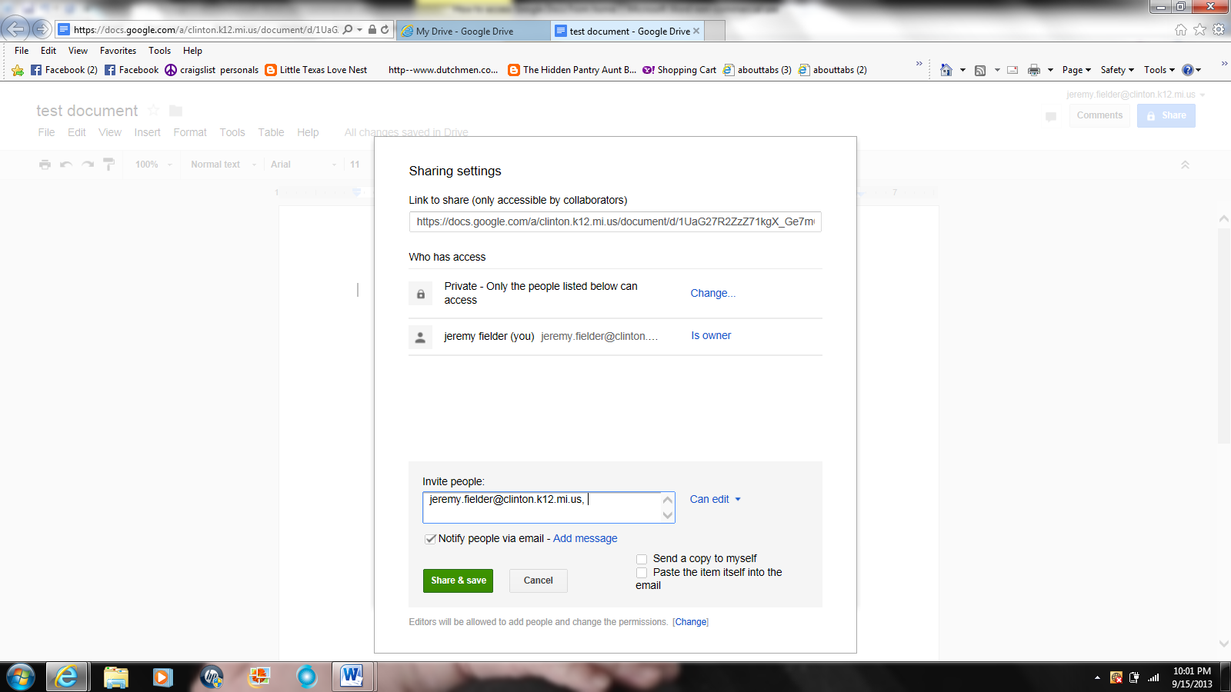
8. Click the drop-down box that says “can edit” and select “can comment.” This way I can give you feedback on the assignment!!

